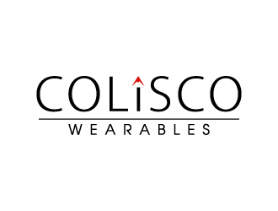
File 1 sample: it is with high resolution for printing.
What are the fonts?
Colisco font?
Wareables font?
Color code number for the icon (red number?)
……………………………………………………………………………………..
File 2 sample:
1. Transparent background
2.Black Backgound
……………………………………………………………………………………
File 3 Sample:
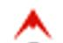
- Icon with high resolution by itself
- Icon with round circle around for sticker printing
………………………………………………………………………………
File 4 sample:
Colisco: myself high resolution
………………………………………………………………………
File 5 sample: with Slogan: what you wear in Colorado with R in the circle for trade mark
